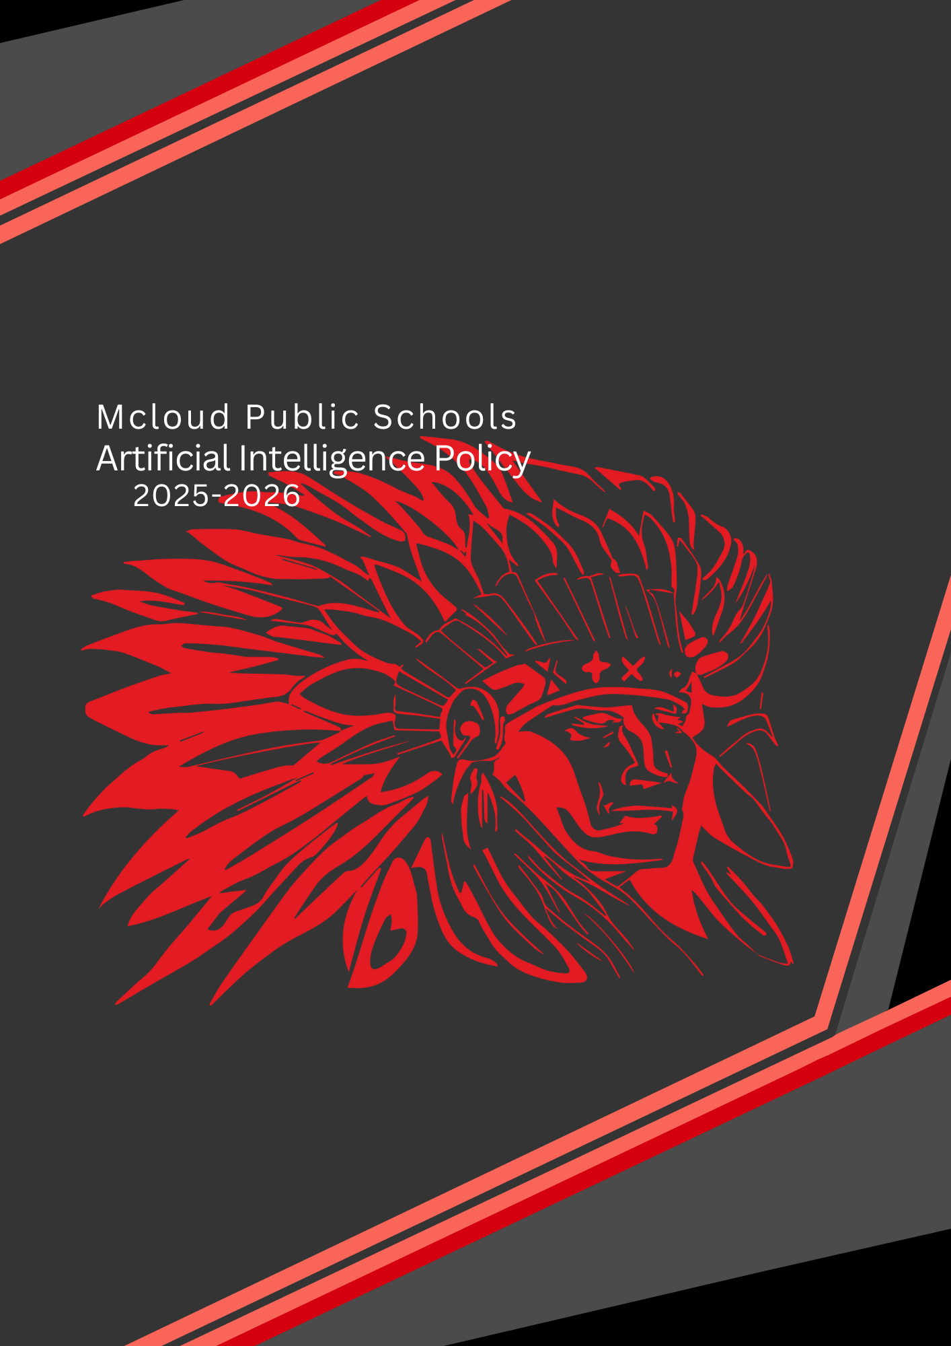

Overview
This Policy applies to all members of the Mcloud Public School District, including students, teachers, administrative staff, and other stakeholders within our school who may use Artificial Intelligence (AI) technologies. It particularly relates to generative AI, such as Large Language Models, but also includes AI tools employed to generate images, video, music, computer code etc., and all other manner of AI usage not stated within.

Rationale:
AI resources are commonly accessible, readily available to teachers and students. These tools are also increasingly integrated into everyday digital resources employed by teachers and students. This policy is needed to ensure safe and acceptable use, aligned with Departmental requirements, school policy and both state and federal laws.

Purpose:
The purpose of this policy is to provide guidelines for the Mcloud Public School District to adhere by the responsible use of AI, prioritizing privacy, security, and ethical considerations.

Our Commitment:
Mcloud Public Schools is committed to using AI in an ethical, transparent, and responsible manner. We acknowledge that AI has the potential to significantly enhance student learning and engagement. We also recognize the importance of protecting student safety, privacy, and academic integrity.

With the responsible integration of AI, our central goals are to augment, not replace, human creativity and critical thinking.

We commit to Prioritize Human Interaction: AI should serve as a tool to enhance, not diminish, student-teacher relationships and peer collaboration. Students rely on human educators for empathy, mentorship, and social development, which AI cannot provide.
The importance of AI The use of AI in Mcloud Public Schools aligns with our mission to provide a high-quality education that prepares our students for success in the 21st century. AI has the potential to support personalized learning and help teachers identify areas where students need extra support. They can also support research and writing activities and provide opportunities for students to develop skills related to critical thinking, problem-solving, and digital literacy.

Technology, including AI, enhances productivity. This document serves as formal recognition at Mcloud Public Schools of the critical importance of AI in the future education and development of young people in our care. It observes our commitment to the ethical use of these tools and introduces their employment within Mcloud Public Schools.

Definitions
Artificial Intelligence (AI): Computer systems or programs that simulate human intelligence, including natural language processing tools that can generate, summarize, or edit text. Examples include ChatGPT, Gemini, Grammarly, Copilot, and similar tools.
AI-Generated Content: Any text, code, images, or other media produced by an AI tool.
Academic Authenticity: The ethical completion of coursework. Examples include appropriately attributing text, pictures, tables, and graphs used in coursework to the creators and each student completing their own coursework, including not submitting work generated by artificial intelligence (AI) as the student’s own work.
Academic Integrity: The commitment to and demonstration of honest and moral behavior in an academic setting, including producing original work and properly attributing sources.
Misuse of AI : The use of AI tools in ways that compromise academic integrity, such as submitting AI-generated work without proper citation or using AI as a substitute for original thought and analysis.

Classroom Considerations, Transparency and Accountability
Teachers are responsible for explaining the limitations and opportunities afforded by AI to students, and the development of the necessary critical thinking skills to employ AI appropriately in support of their learning. It is a teacher’s responsibility to appropriately prepare students if they are asked to employ AI within a sequence of learning, to understand the bias, limitations and possible ethical considerations that may arise when using AI.

Review and Verify Content:
Staff and students must critically review any AI-generated content for accuracy, as AI models can "hallucinate" or provide incorrect information.

Promote AI Literacy:
Students and staff must develop a critical understanding of how AI works, its limitations, and its ethical implications. This includes teaching students how to identify and evaluate potential biases or misinformation generated by AI.

Assignment-Specific Rules:
Teachers should set explicit, assignment-specific rules regarding AI use to combat misuse and expand useful integration. This could range from requiring original writing as well as a polished AI augmented final work, limiting use for brainstorming, or full integration for data analysis.

Focus on the Process and Human-Centric Approaches:
Teachers can design assignments that emphasize the learning process, not just the final product. Encourage students to use AI to build upon original ideas. For instance, students could submit their ChatGPT prompts and critique the AI's response to demonstrate critical thinking or input their own essay outline and analyze the response to improve their understanding.

Acceptable Use
AI tools should be employed transparently, with clear guidelines to maintain academic integrity, particularly in assessments where their use should support but not replace, human judgment. Teachers may use AI to support the critical evaluation of student work, but not as the main assessment method. Given AI tools are known to provide assessments of understanding in a way that can be biased or factually inaccurate, these resources must only be used in support of and not in place of assessment. It is expected that teachers will use a broad range of data and multiple forms of assessment to support student learning. Where AI is employed by students, teachers may require students to identify the types of AI resources they drew on in the development of their work. Where AI has been used by staff, particularly in program development, it should not be employed as a single point of reference, nor should it use without appropriate citation. Where ChatGPT for example has been used to support the development of content for a course, it should be acknowledged.

Data Privacy, Security, and Equity:
Protect Student Privacy and Data: The school must ensure compliance with regulations like FERPA and require parental consent for minors when using AI systems that collect vast amounts of student data. Any AI tool used should have strong security measures and clear data retention policies.

Ensure Equitable Access:
The school must work to close the digital divide and ensure that all students have equal access to AI tools, regardless of their socioeconomic status. Policies should also address potential biases in AI algorithms that could lead to unfair outcomes for marginalized student groups.

Responsibilities:
The following individuals and groups are responsible for the implementation and maintenance of this guiding document:

School leadership:
responsible for providing resources, guidance, and support for implementing these guidelines , including providing professional development for all staff on AI technologies to help them understand how to integrate these tools effectively into the curriculum.
Teachers:
responsible for implementing the guidelines in their classrooms, including providing instruction on the ethical and responsible use of AI. Teachers can model effective and ethical AI use in the classroom by collaborating with the tools themselves to create lesson plans, summarize texts, or generate study questions.
Instructional Leaders:
responsible for guiding teachers in the pursuit of best practice in the use of AI in classrooms and course development.
Administrative staff: responsible for ensuring that AI is used in compliance with the guidelines, including data privacy and security policies.
Students: responsible for using AI in an ethical and responsible manner, as outlined in the guidelines.
Parents/guardians: responsible for supporting their children's appropriate and ethical use of AI in compliance with these guidelines.

AI Governance and Continuous Assessment
Empower Educators: The policy ensures that educators retain ultimate authority over their classroom and students' education. AI tools should augment, not replace, their professional judgment and instincts.

AI Advisory Board: The district shall establish an AI advisory board, a committee of diverse stakeholders—including educators, administrators, parents, and students—to review AI tools, establish ethical standards, and develop guidance as the technology evolves.

Decisions supported by AI tools will remain under the ultimate control of our educators and administrative team, ensuring human responsibility and accountability.

Guidelines: Review and Approval The use and impact of AI tools within our community will be actively and regularly monitored, with procedures in place to identify and manage emerging risks and opportunities. We will establish procedures for monitoring AI use and managing its impact, providing opportunities for our community to question and challenge the use of these technologies.

Continuous Evaluation: The district shall implement a plan for continuous evaluation and feedback to measure the impact of AI on student learning outcomes. This allows for adjustments to be made to the policy as needed. This commitment includes an annual review of the Mcloud Public Schools AI Policy to ensure our AI practices remain aligned with the evolving educational landscape and technological advancements.

Created By:
Created Date:
Reviewed:
Approved By:
Approval Date:
Next Review Date:

